**Sivakumar M 20MIA1002**

**Vellore Institute of Technology -Chennai**

**Power BI Documentation**

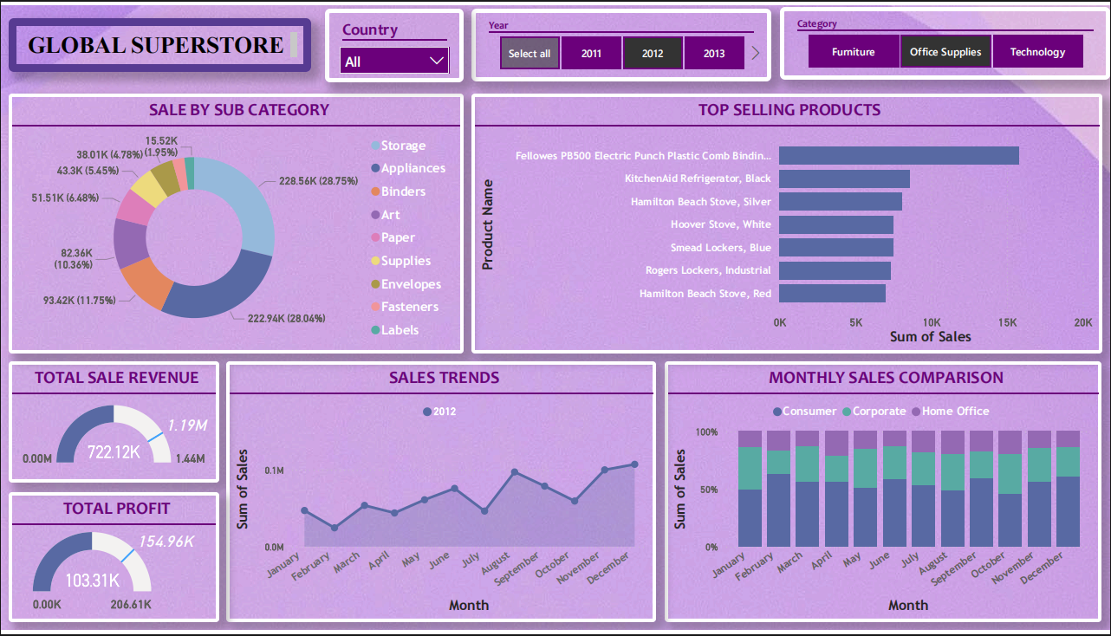

**Fig:** Dashboard Preview

Slicer:

* ***Country:*** Dropdown Style for selection of desired listed country.
* ***Year:*** Tiles Style for selecting of Years, since there are only 4 discrete years.
* ***Category:*** Tiles Style for selecting of Category, since there are only 3 discrete categories.

Visualizations:

* ***Total Sales Revenue:*** For this visualization a separate columns is created with the formula

Total Sales Revenue = 'Global-Superstore - Global-Superstore csv'[Sales] - 'Global-Superstore - Global-Superstore csv'[Sales] * 'Global-Superstore - Global-Superstore csv'[Discount]

To visualize this Gauge Chart has been used with the Target Variable (measure) as Key Parameter Indicator (KPIs)

Target Sale = SUM('Global-Superstore - Global-Superstore csv'[Sales]) * 1.5

Similarly, ***Total Profit*** also created with Target Variable (measure),

Target Profit = SUM('Global-Superstore - Global-Superstore csv'[Profit]) * 1.5

* ***Sales By Sub-Categories:*** Donut Chart is used to segregate the Sub-Categories division among selected Category from the Slicer.This visualization is also used to Highlight and interact with other visualizations. To provide the niche information regard that Sub-Category

**Example:**

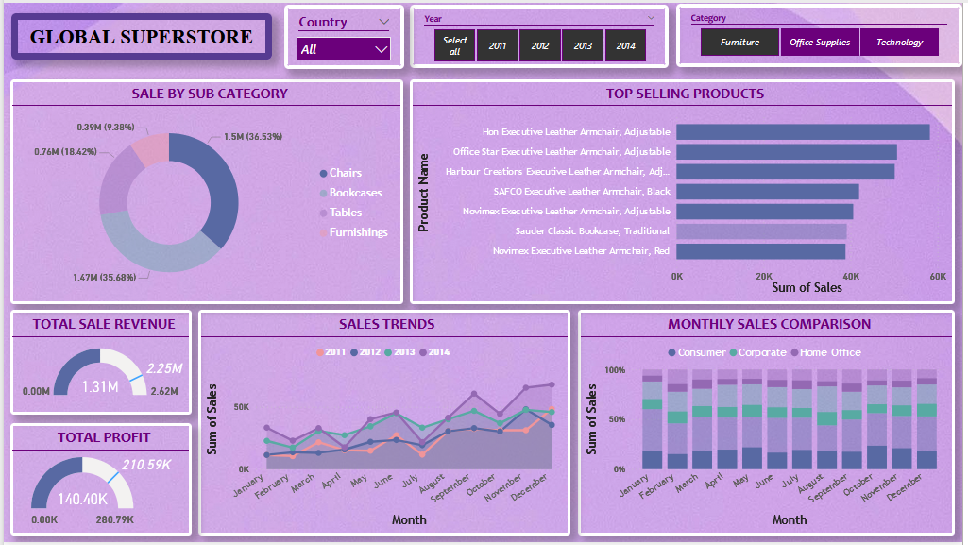

**Now, Sub-Category Chairs are Highlighted and all the other visualizations are also highlighted with corresponding data to provide insights about Chair sub-category.**

* ***Top Selling Products:***  Cluster Bar Chart is used to visualize the Top N products from each Category of Products. Product Name as Y-axis and Sales as X-axis.

Go to Filters, then select Filter Type as “Top N” and you can choose the number of elements to be displayed.

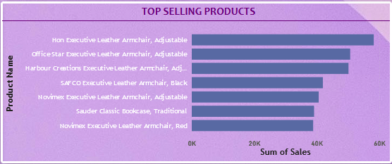

* ***Sale Trends:*** Line chart is used with Months in X- axis and Sale Trend in Y-axis. Year and Category based trends can be visualized through this chart.

**Example:**

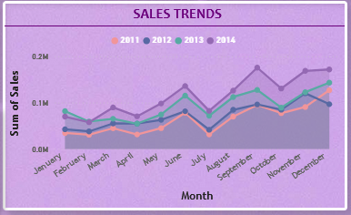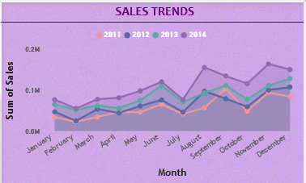  
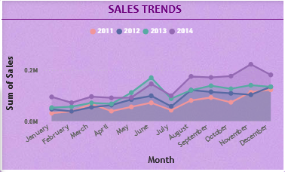

**From all these visualizations, we can notice a sudden dip in sales in the Month of JULY.**

* ***Monthly Sales Comparison:*** Stacked Column chart is used to compare monthly sales with respect to Customer Segment. This visualization interacts with Total Sale Revenue, Total Profit gained from the particular month and customer segment.

**Example:**

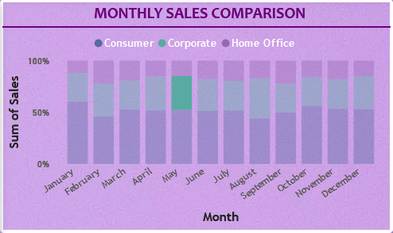

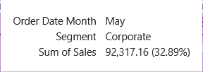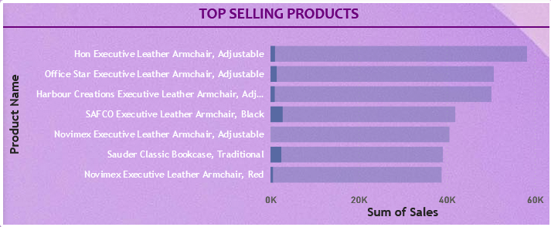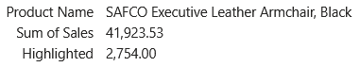

**These images show the Highlights stats from Corporate purchase in May month, Sales of particular product on the time frame is Highlighted in the Top Selling Products.**